

|  |
| --- |
| **VILNIAUS KOLEGIJA**  **ELECTRONICS AND INFORMATICS FACULTY**  **SOFTWARE DEVELOPMENT DEPARTMENT** |
| Hybrid Mobile Application  FINAL PROJECT  PI18E |
| **Pizza Delivery app and Pizza Worker app** |
|  |
| |  |  |  | | --- | --- | --- | | STUDENT | 2020 - __ - __ | Phumin P. | | LECTURER | 2020 - __ - __ | Justinas  Zailskas | |
| 2020, VILNIUS |

**Content:**

1. Introduction.
2. Functional and Non-Functional requirements.
3. Database logical Design.
4. List of development tools and software used for the project.
5. Software Installation Guide.

**1.Introduction:**

The project is about the Pizza Delivery Application for Restaurants whose main aim is to order the pizza online within a minute. Pizza worker application is used to keep updating the order status of customer’s order where the communication between two applications occurs using firebase.

**2.Functional and Non-Functional Requirements:**

**2.1: Functional requirements**

1. Registration of customer using mobile number, name, password.
2. Login using mobile number and password.
3. Browse the pizza’s by categories.
4. Add to cart pizza or other beverages.
5. Clear cart feature / update the cart feature.
6. Place an order.
7. View My Orders Section.
8. Check the order status.
9. Logout feature.

**2.2: Non-Functional requirements**

1. Registration screen design.
2. Login screen design.
3. Home screen design.
4. Products screen design.
5. Cart screen design.
6. My Orders screen design.

**3.Database logical design:**

1. Customer’s table: This table is used for the registration and login and used to store cart items of customer’s.
2. Products table: This table is used to fetch the category wise pizza / beverages.
3. Orders table: This table is used to add orders from customers from cart items.
4. Order details: This table is used to store the order details like products and quantity within an order id.
5. Workers: This table is used for registration and login of workers (update the status of the orders).

**Use case diagram:**

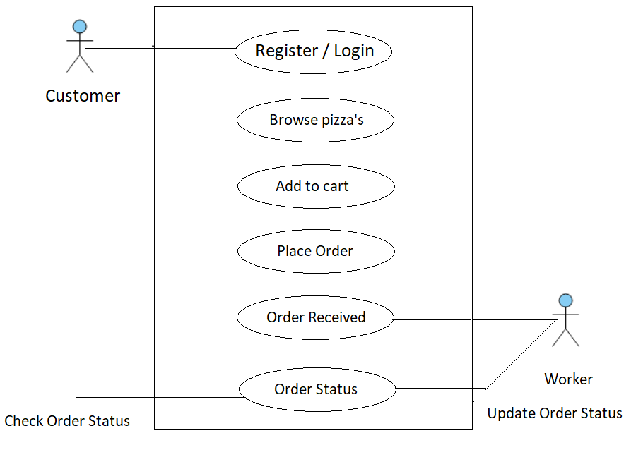

**4.List of development tools and software used:**

1. Android studio.
2. Flutter and dart plugin.
3. Java Development Toolkit.
4. AVD ( to test and run the application).

**5.Software Installation Guide:**

1. Android studio: This software can be downloaded from the link <https://developer.android.com/studio> and normal installation procedure can be followed to install the software. Once the studio is downloaded then SDK is required to installed from the android studio by going from Menu --> Tools --> Sdk Manager
2. Flutter and dart plugin: This plugin can be installed from the android studio itself by going from Menu --> Settings --> Plugins -- > Search flutter and dart. Select flutter and dart then restart the android studio.
3. JDK can be download from <https://www.oracle.com/in/java/technologies/javase-jdk11-downloads.html> and normal installation procedure can be followed.
4. AVD ( Android Virtual Device): It can be downloaded from the Android studio itself by going from Menu --> Tools --> AVD Manager.